Project Design Phase
Solution Architecture
Date | 5 September 2026
Student Name | Bantupalli Niharika
Project Name | Automated Network Request Management
Maximum Marks

Solution Architecture
The architecture connects the Service Portal, Network Request Catalog, validation rules, approval process, and Network Tasks to manage network requests efficiently.
Figure 1: Solution architecture for the Automated Network Request Management project.
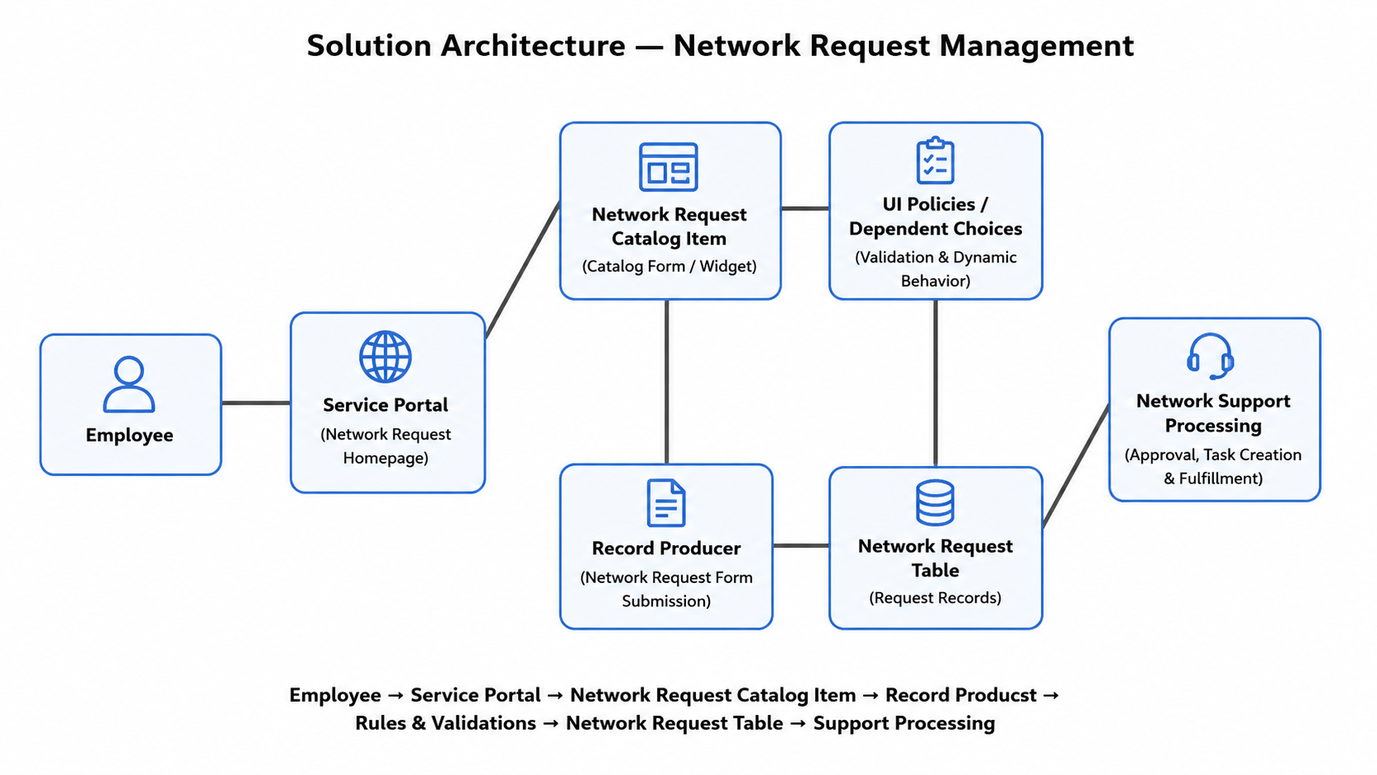
Figure 1: Solution architecture for the Automated Network Request Management project.
Layer | Components | Responsibility
Experience | Service Portal, Network Request Catalog | Employee request interface.
Interaction | Catalog Client Scripts, UI Actions | Controls form interaction and behavior.
Catalog | Network Request Catalog Item | Collects network request details.
Rules | Catalog UI Policies, Client Scripts | Validates and controls fields.
Automation | Flow Designer, Approvals | Processes approvals and creates tasks.
Data | REQ, RITM, Network Tasks | Stores request and fulfillment records.
References | sys_user, sys_user_group | Stores user and group reference data.

